**Task 1 (a)**

1. **Creating Four Files and Two Directories** →touch 22341082_1.txt 22341082_2.txt 22341082_3.txt 22341082_4.txt; mkdir badhon1 badhon2



1. **Moving txt file** →mv 22341082_1.txt 22341082_2.txt 22341082_3.txt badhon1
2. **Copying One Directory to Another** →cp 22341082_1.txt 22341082_2.txt ~/Code/321_Assignment_1/badhon2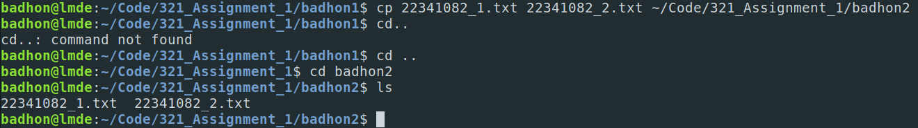
3. **Creating Another Directory** → mkdir badhon3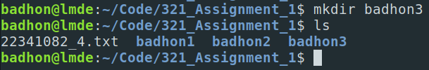
4. **Copying One DIrectory to Another** →cp -r badhon1 badhon3; cd badhon3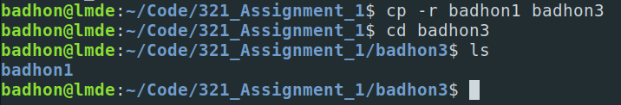
5. **Checking and Changing the Permission** →ls -l;sudo chmod -R go=rx badhon1;ls -l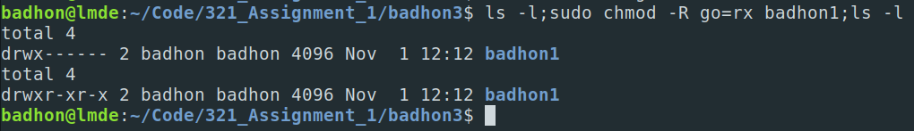
6. **Going Back One Directory** → cd ..;ls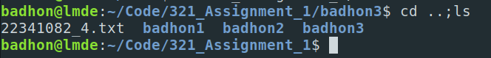
7. **Moving Folder to Root Directory** →sudo mv badhon3 /

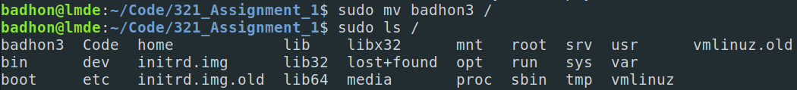

1. **Deleting Everything** → rm -r ~/Code/321_Assignment_1

**Task - 1(b)**

* **Creating a txt File with Course Details** → echo -e "CSE321-Operating System-Sec7\nCSE331-Theory of Computation-Sec11\nCSE370-Database System-Sec11\nMAT215-MATH III Complex Variables and Laplace Transformations-Sec1" > course_list.txt
* **Counting the “CSE” Word** → grep -c "CSE" course_list.txt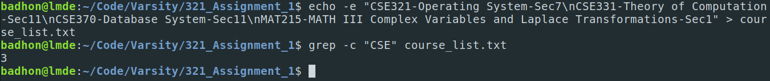

**Task -1(c)**

* **Showing Hidden Folder on Root Directory** → sudo ls -a /

**Task -1(d)**

* **Show only lines 5-17** → sed -n '5,17p' cat.txt